

**Project Report**

**Course:** CSE301

**Course Title:** Database System

**Section:** 02

**Semester:** Spring-2021

**Project Title:** Restaurant Management System

**Group No.: 07**

**Submitted to:**

**Md Mostofa Kamal Rasel**

**Assistant Professor,**

**Department of Computer Science & Engineering,**

**East West University.**

**Submitted by:**

|  |  |
| --- | --- |
| Name & ID | Responsibilities % |
| Md. Tanvir Hassan  2018-1-60-236 | **33.34%** |
| Sohel Rana  2017-3-60-043 | **33.33%** |
| Nur-A-Rayana  2018-1-60-131 | **33.33%** |

**Date of Report Submission:** **25 May, 2021**

**Contents**

1. **Introduction**
2. **Data types**
3. **Data Requirements**
   * 1. **Entities**
     2. **Attributes**
4. **4.Design Description**
5. **Entity Relationship Diagram**
6. **ER Diagram to Relational Schema Diagram**
7. **ER Diagram to Relational Schema to SQL statements**
8. **Execute in Xampp Control Panel**
9. **Relation table**
10. **Conclusion**

**1.Introduction:**

The Restaurant management system is a web application system which are generally small or medium in size and this system is to automate day to day activity of a restaurant. It is basically used by restaurants to manage the restaurants record using the employee details, customer details address, order details, item list, Offer, delivery man details etc.

It uses different entities to provide best service to customer.

**2. Data Types:**

**1. Integer:** One optional sign character (+ or -) followed by a least one digit (0-9).

Leading and trailing blanks are ignored. No other character is allowed.

**2. Varchar:** It used to store alpha numeric characters. In this data type we can set the

maximum number of characters up to 8000 ranges by defaults SQL server will set the size to 50 characters range.

**3. Date:** The DATE data type accepts date values. No parameters are required when

declaring a DATE data type. Date values should be specified in the form:

YYYY-MM-DD. However, point base will also accept single digits entries foe month and day values.

**4. Time:** The TIME data type accepts time values. No parameters are required when

declaring a TIME data type. Date values should be specified in the form: HH:MM: SS. An optional fractional value can be used to represent nanoseconds.

**3.Data requirements:**

* **Entities:**
  + - * Customer
      * Customer_Rank
      * Orders
      * Address
      * Employee
      * Payment
      * Discount
      * Item
      * Delivery Man
* **Attributes:**
* **Customer:**
  + ID
  + Name
  + Email
  + Phone Number
  + Address
* **Customer_Rank:**
  + R_ID
  + Regular
  + Goldem
  + Platinum
* **Orders:**
  + Order_ ID
  + Order _time
  + Customer_ id
  + Total purchase
  + Order _date
  + Del_status
  + R_ID
* **Payment:**
* P_id
* Card
* bkash
* **Food_Item:**
* Item_ID
* Item_name
* Price
* Description
* Rating
* **Delivery boy:**
* D_ID
* Area_code
* Name
* Phone
* Salary
* **Address:**
* Address_ID
* city
* Post_code
* Area_code
* Street
* Road_No
* House_No
* **Employee:**
  + Emp_id
  + Name
  + Salary
  + Adress
  + Phone Number
* **Discount:**
  + Offer_Id
  + Status

**4.Design Description:**

In our Restaurant management system’s design, we want to give an online service. We have nine entities. Customers can order through online and able to see our food items and quality. We have another entity delivery boy to manage the delivery to the particular address. The delivery boy has an area code to give service in a particular area according to area code. In this design, we have a payment entity and discount entity. Two types of payment are available they are card and bkash. Discount is available according to customer rank.

**5.Entity-Relationship- Diagram:**

An Entity Relationship Diagram (ERD) is a visual representation of different entities within a system and how they relate to each other.

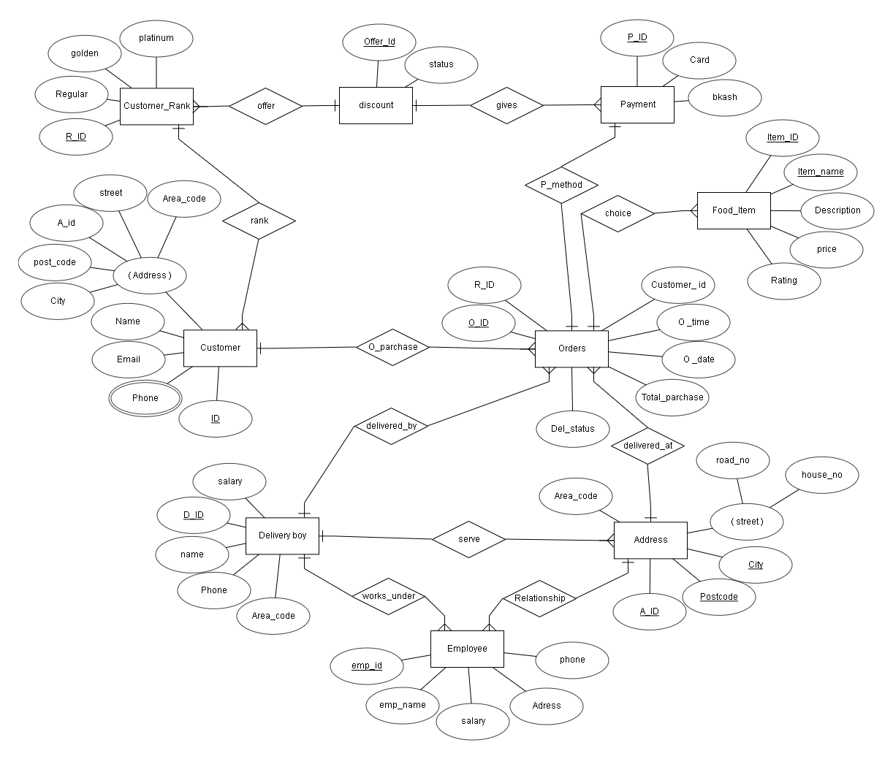

Here in the diagram, we have **nine** Entities**: customer, customer_rank, address, employee, delivery boy, item, payment, offer and orders.**

**Customer** has five attributes: ID, User Name, phone, Email and address. Phone. **ID** is the primary key; **phone number** is multivalued attribute and **address** is composite attribute.

**Customer_Rank** has five attributes: R_ID, regular, golden, and platinum. Here, **R_ID** is the primary key

**Address** has five attributes: A_id, Area_code, City, post_code, and street. **A_id, post_code** and **city** are primary key and **street** is composite attribute.

**Employee** has five attributes: emo_id, emp_name, status, salary, address. Here **emp_id** is primary key.

**Delivery boy** has five attributes: D_ID, Area_code, name,salary and phone. Here, **D_ID** is primary key.

**Food_Item** has five attributes: item_id, item_name, price, description, and rating. **item_id** and **item_name** is primary key.

**Payment** has three attributes: P_id, card, bkash. Here, **P_id** is primary key.

**Discount** has two attributes: offer_id, and status. Here, **offer_id** is primary key.

**Orders** has seven attributes: O_ID, O_time, O_date, customer_id,del_status, total_purchase and R_ID. Here, **O_ ID** is primary key.

**6. ER Diagram to Relational Schema:**

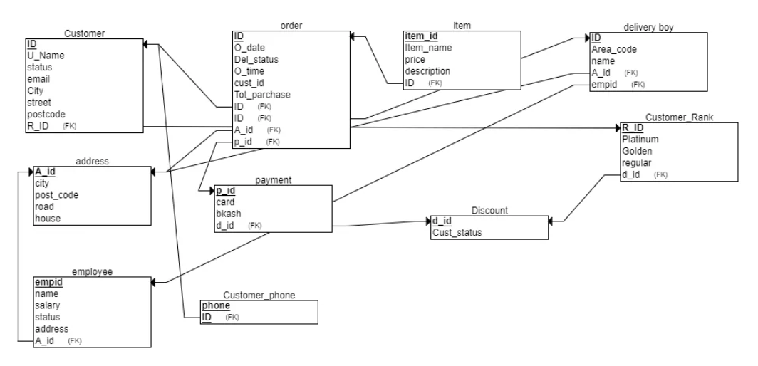

**7.ER Diagram to Relational Schema to SQL statements:**

**SQL>**

CREATE TABLE address

(

A_id INT(10) NOT NULL,

city varchar(45) NOT NULL,

post_code INT(10) NOT NULL,

road varchar(45) NOT NULL,

house varchar(45) NOT NULL,

PRIMARY KEY (A_id)

);

CREATE TABLE Discount

(

d_id INT(10) NOT NULL,

Cust_status varchar(45) NOT NULL,

PRIMARY KEY (d_id)

);

CREATE TABLE Customer_Rank

(

Platinum varchar(45) NOT NULL,

Golden varchar(45) NOT NULL,

R_ID INT(10) NOT NULL,

regular varchar(45) NOT NULL,

d_id INT(10) NOT NULL,

PRIMARY KEY (R_ID),

FOREIGN KEY (d_id) REFERENCES Discount(d_id)

);

CREATE TABLE employee

(

empid INT(10) NOT NULL,

name varchar(45) NOT NULL,

salary numeric(10,2) NOT NULL,

status varchar(45) NOT NULL,

address varchar(45) NOT NULL,

A_id INT(10) NOT NULL,

PRIMARY KEY (empid),

FOREIGN KEY (A_id) REFERENCES address(A_id)

);

CREATE TABLE Customer

(

ID INT(10) NOT NULL,

U_Name varchar(45) NOT NULL,

status varchar(45) NOT NULL,

email varchar(45) NOT NULL,

City varchar(45) NOT NULL,

street varchar(45) NOT NULL,

postcode INT(10) NOT NULL,

R_ID INT(10) NOT NULL,

PRIMARY KEY (ID),

FOREIGN KEY (R_ID) REFERENCES Customer_Rank(R_ID)

);

CREATE TABLE delivery_boy

(

ID INT(10) NOT NULL,

Area_code varchar(45) NOT NULL,

name varchar(45) NOT NULL,

A_id INT(10) NOT NULL,

empid INT(10) NOT NULL,

PRIMARY KEY (ID),

FOREIGN KEY (A_id) REFERENCES address(A_id),

FOREIGN KEY (empid) REFERENCES employee(empid)

);

CREATE TABLE payment

(

card INT(10) NOT NULL,

p_id INT(10) NOT NULL,

bkash INT(10) NOT NULL,

d_id INT(10) NOT NULL,

PRIMARY KEY (p_id),

FOREIGN KEY (d_id) REFERENCES Discount(d_id)

);

CREATE TABLE Customer_phone

(

phone varchar(45) NOT NULL,

ID INT(10) NOT NULL,

PRIMARY KEY (phone, ID),

FOREIGN KEY (ID) REFERENCES Customer(ID)

);

CREATE TABLE order_item

(

O_date DATE NOT NULL,

Del_status varchar(45) NOT NULL,

O_time TIME NOT NULL,

cust_id INT NOT NULL,

Tot_parchase INT(10) NOT NULL,

ID INT NOT NULL,

A_id INT NOT NULL,

p_id INT NOT NULL,

PRIMARY KEY (ID),

FOREIGN KEY (A_id) REFERENCES address(A_id),

FOREIGN KEY (p_id) REFERENCES payment(p_id)

);

CREATE TABLE item

(

Item_name varchar(45) NOT NULL,

item_id INT(10) NOT NULL,

price INT(10) NOT NULL,

description varchar(45) NOT NULL,

ID INT(10) NOT NULL,

PRIMARY KEY (item_id),

FOREIGN KEY (ID) REFERENCES order(ID)

);

**8.****Execute in Xampp Control Panel:**

Successfully executed in xampp control panel**.**

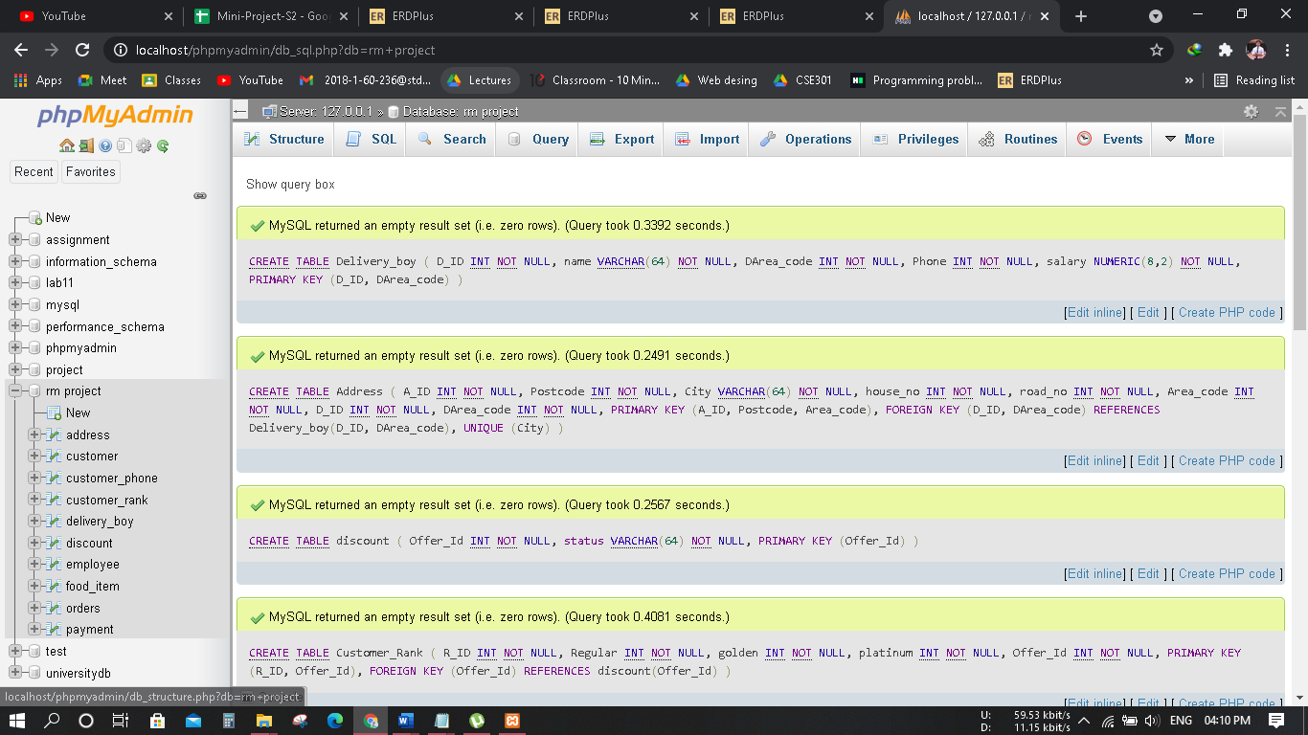

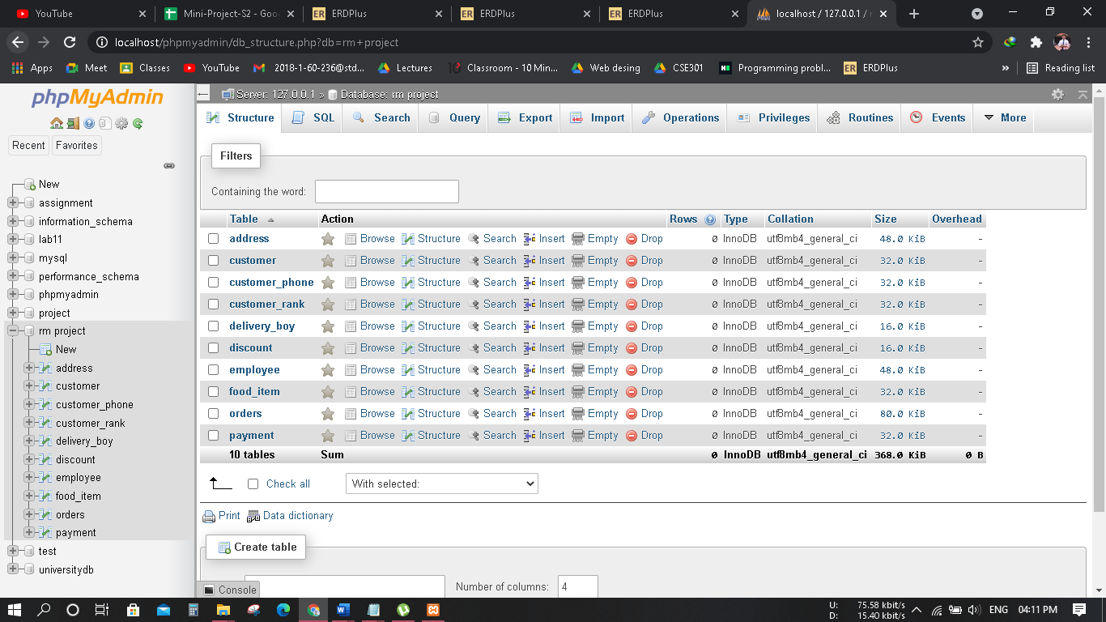

**Insert queries**

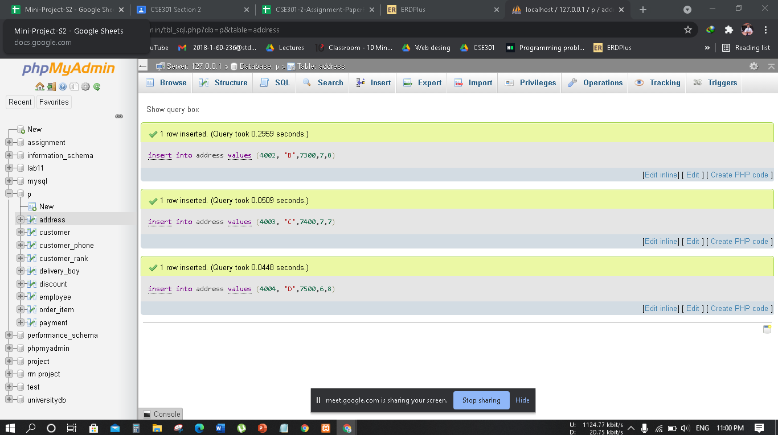

**Select queries:**

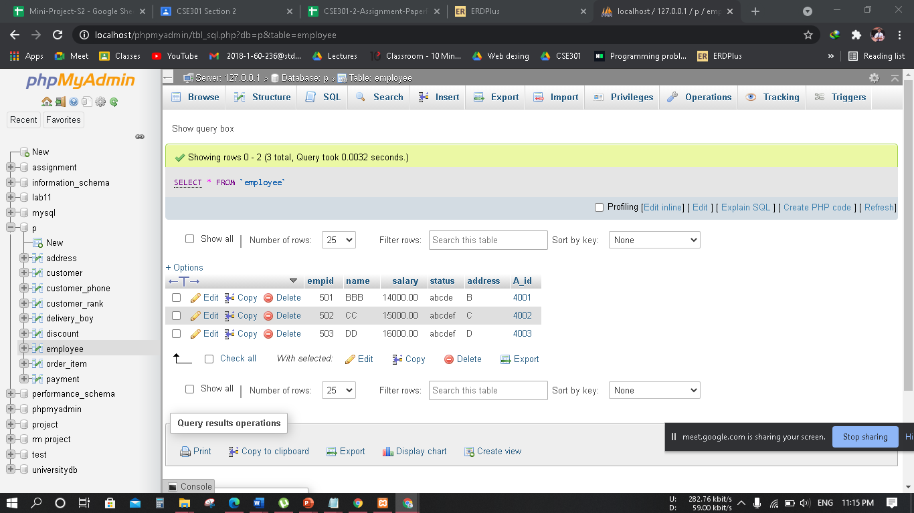

**Update queries:**

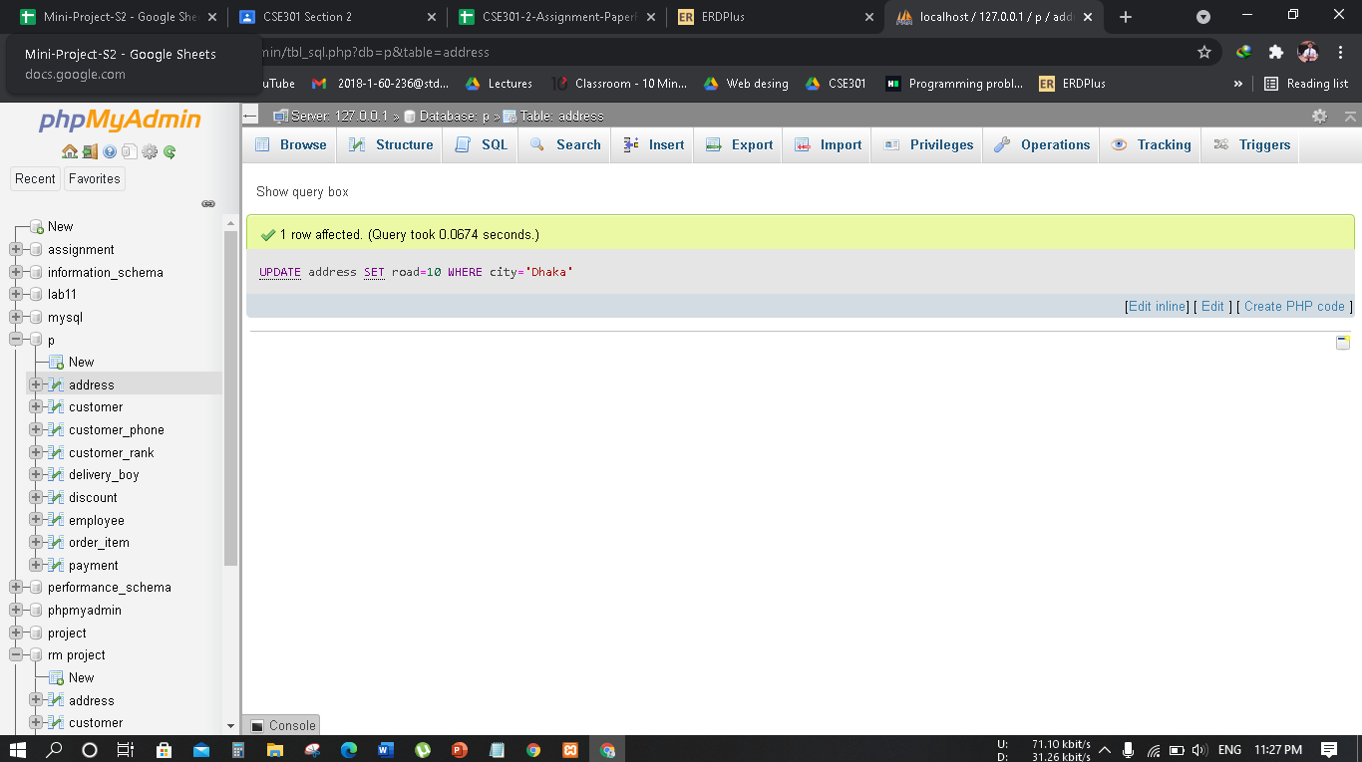

**Natural join queries:**

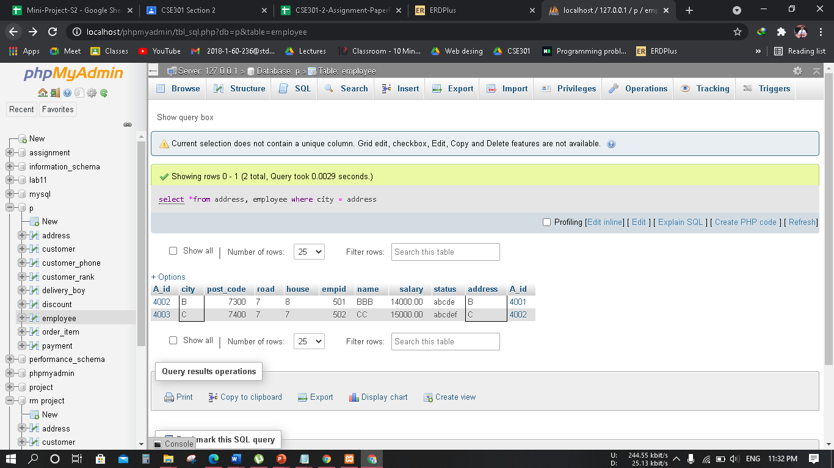

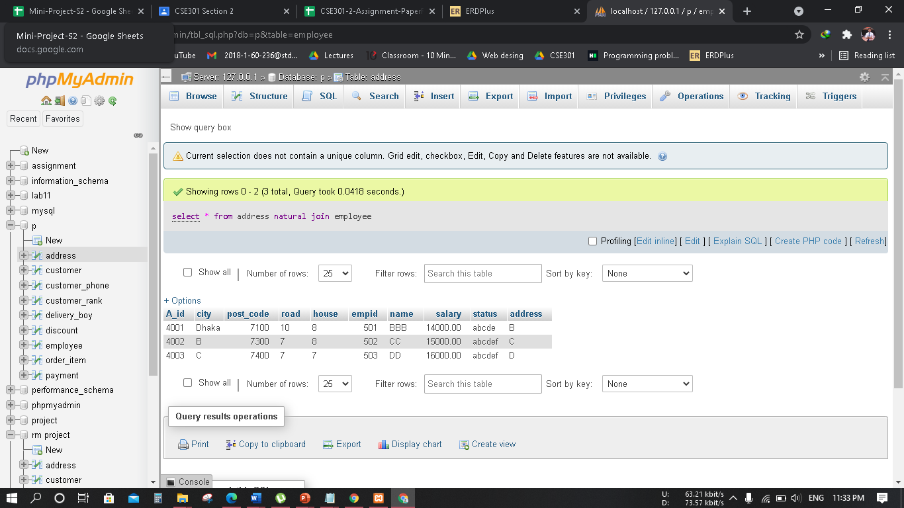

**Delete queries:**

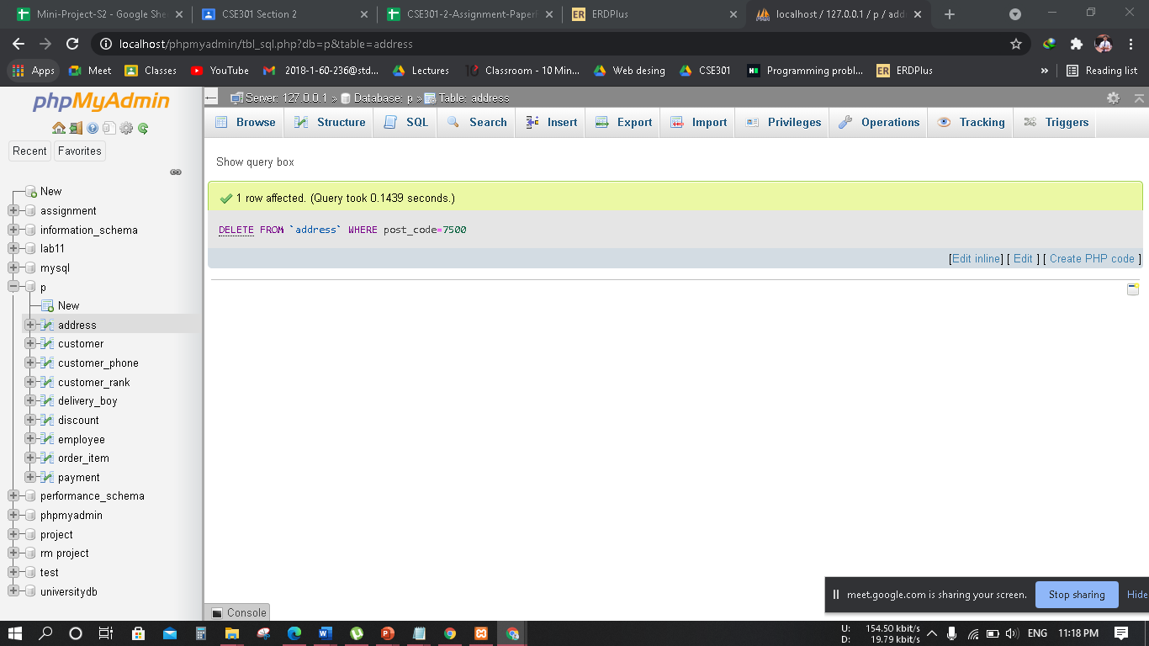

**9.Relationship table:**

|  |  |
| --- | --- |
| Entity | Relationship |
| Customer – Customer Rank | n-1 |
| Discount – Customer Rank | n-1 |
| Discount – payment | 1-n |
| Order - payment | 1-1 |
| Order -Item | 1-n |
| Order – Delivery Boy | n-1 |
| Employee - Delivery Boy | 1-n |
| Employee- Delivery Boy | 1-n |
| Employee- Address | n-1 |
| Address - Delivery Boy | 1-n |
| Order – Address | n-1 |
| Customer – order | 1-n |

**10.Conclusion:**

SQL database the board application which is very much utilized in the advanced world in getting sorted out and controlling a database. Despite the fact that SQL doesn't have the GUI interface like Microsoft access is having and they all deal with the database agreeable. Contingent upon the client or clients, on the off chance that an association has different clients, at that point they should go for SQL worker-based application. This undertaking tells the best way to make tables in SQL and how to make basic information control language and information definition language with how to execute them. It likewise shows how connections are set up with the ideas of essential and unfamiliar key inside a table. Finally, the undertaking shows how questions are made in SQL worker, inquiries like the make order, see, update, modify and so on.

In conclusion, the Restaurant Management system helps the customer to order online and help the restaurant work to run the restaurant business.